

SHUBH MITTAL

ROLL NO: - 24/SCA/BCA/047

DATA STRUCTURE LAB

PROGRAM -1: - Write a data structure program Find Largest Value of an Array. Shubh Mittal 24/SCA/BCA/047

CODE:1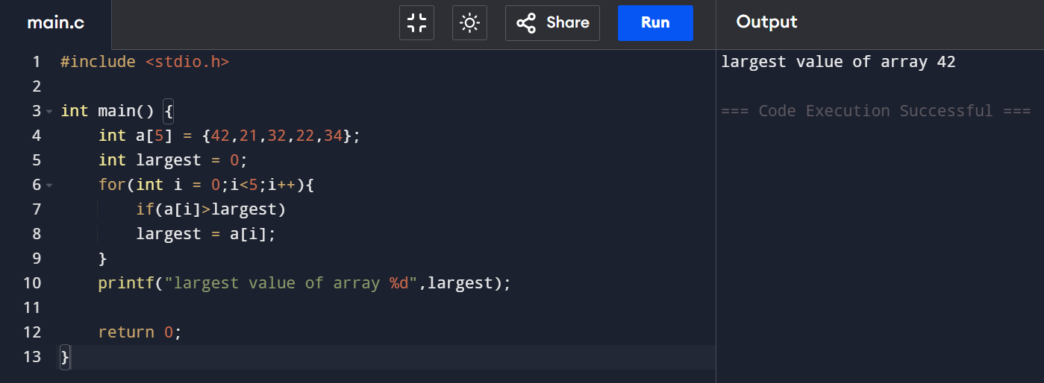

.

PROGRAM -2: - Write a data structure program to find electricity bill. (Using if Statement) Shubh Mittal 24/SCA/BCA/047

CODE:2 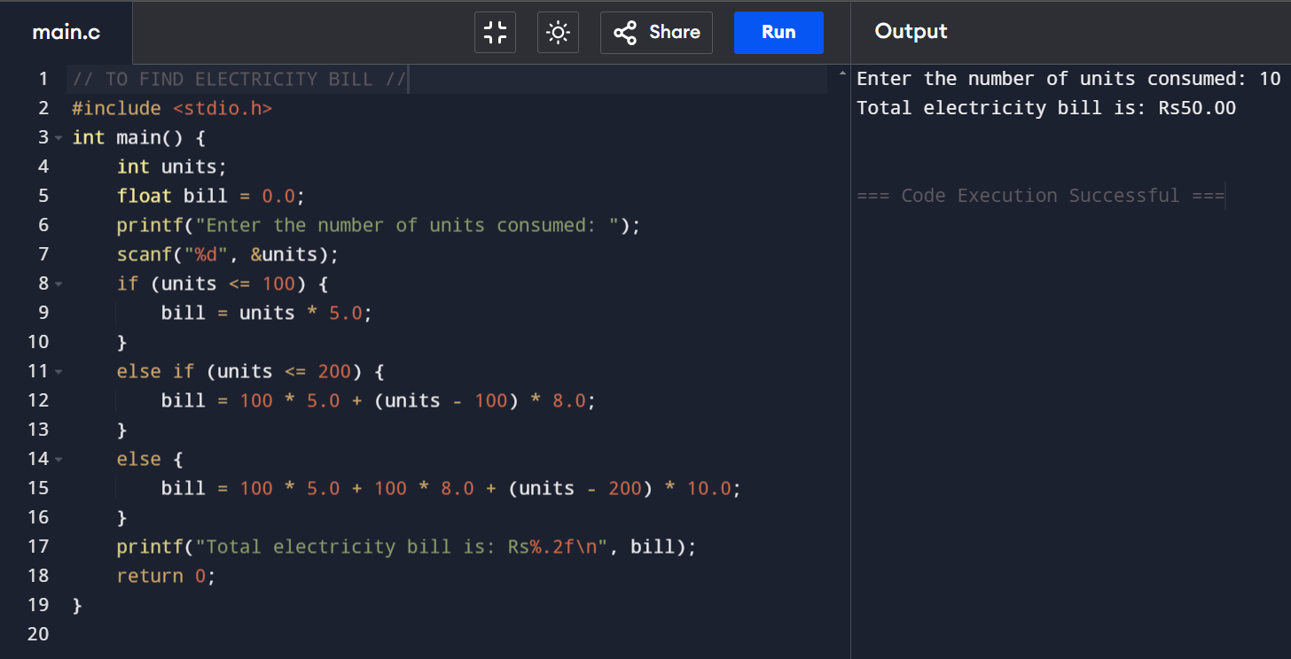

PROGRAM -3: - Write a data structure program to Print Three Numbers where is smallest and largest. Shubh Mittal 24/SCA/BCA/047

CODE:3

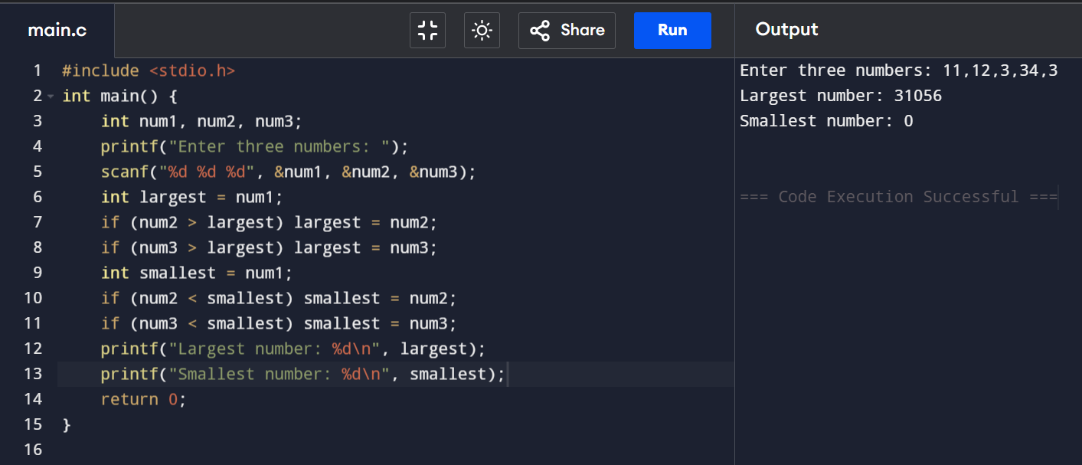

PROGRAM -4: - Write a data structure program to declare an array and also find the values in it. Shubh Mittal 24/SCA/BCA/047

CODE:4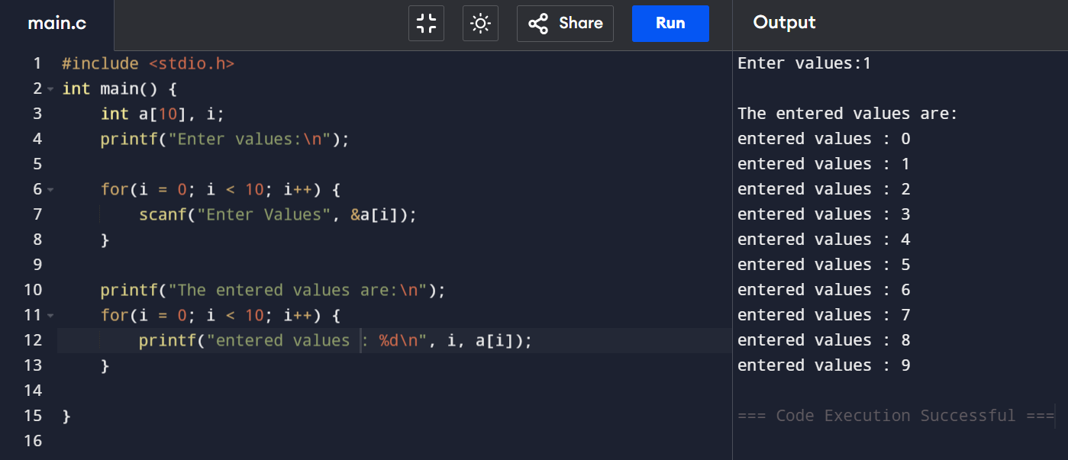

PROGRAM -5: - Write a data structure program to insertion of an Array. Shubh Mittal 24/SCA/BCA/047

CODE:5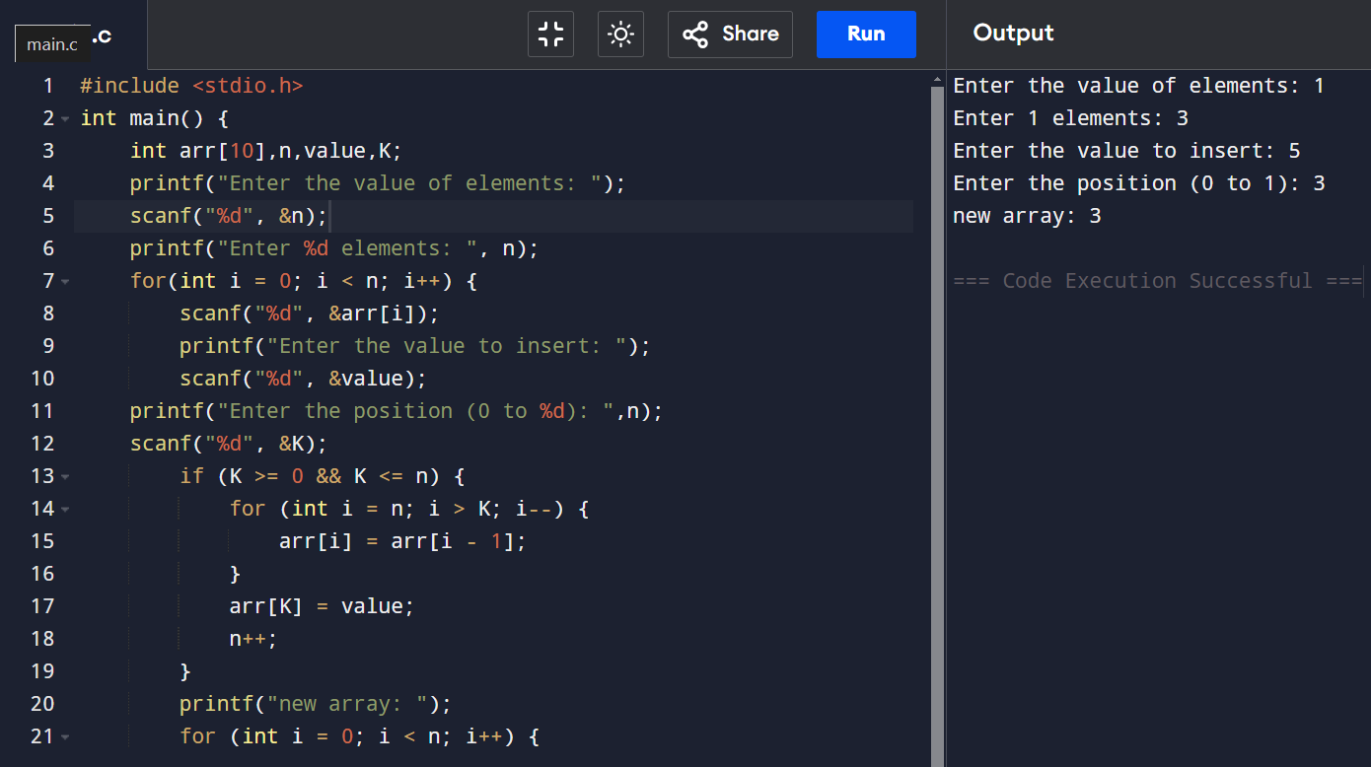

PROGRAM -6: - Write a data structure program to enter the marks and find the sum and average. Shubh Mittal 24/SCA/BCA/047

CODE:6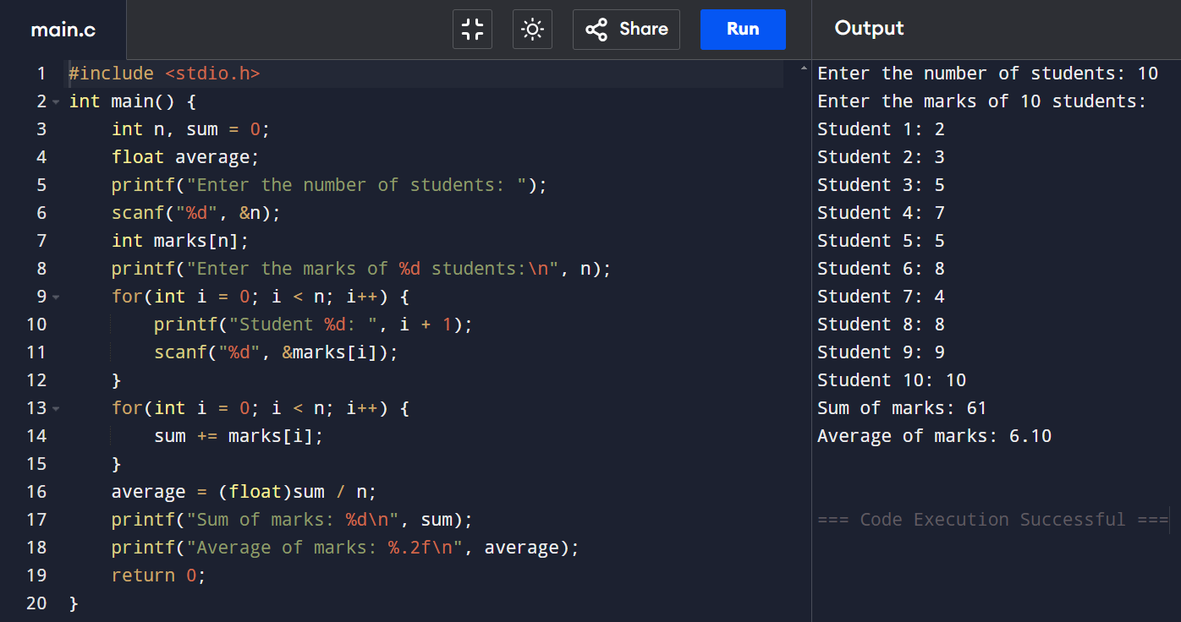

PROGRAM -7: - Write a data structure program to enter the Traversed arrays elements. Shubh Mittal 24/SCA/BCA/047

CODE:7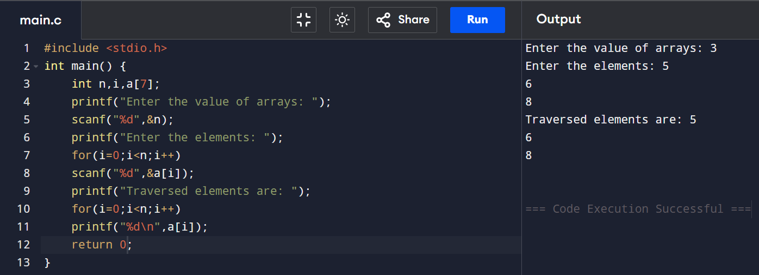

PROGRAM -8: - Write a data structure program to delete an array. Shubh Mittal 24/SCA/BCA/047

CODE:8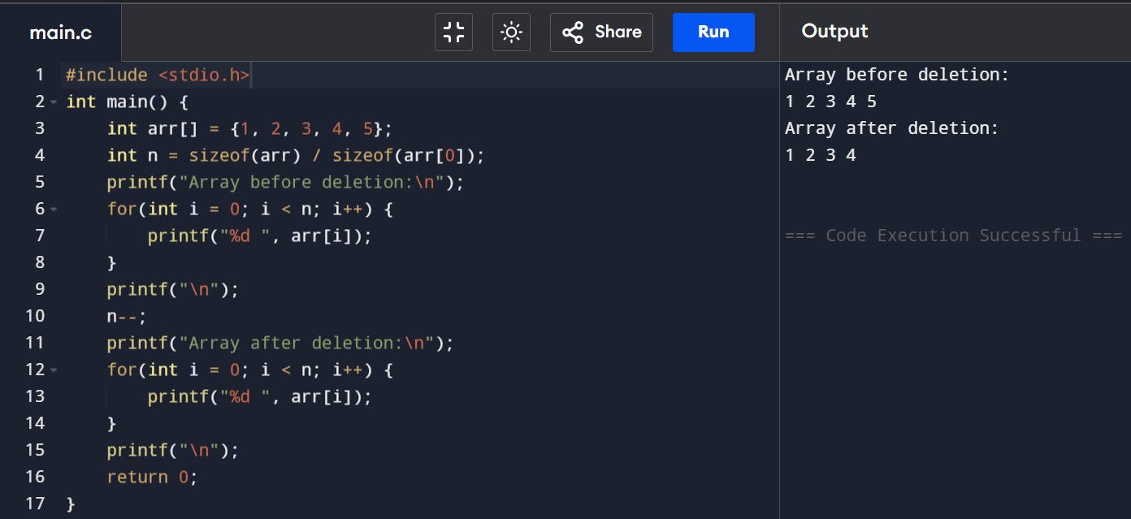

PROGRAM -9: - Write a data structure program to find sum of n natural numbers. Shubh Mittal 24/SCA/BCA/047

CODE:9 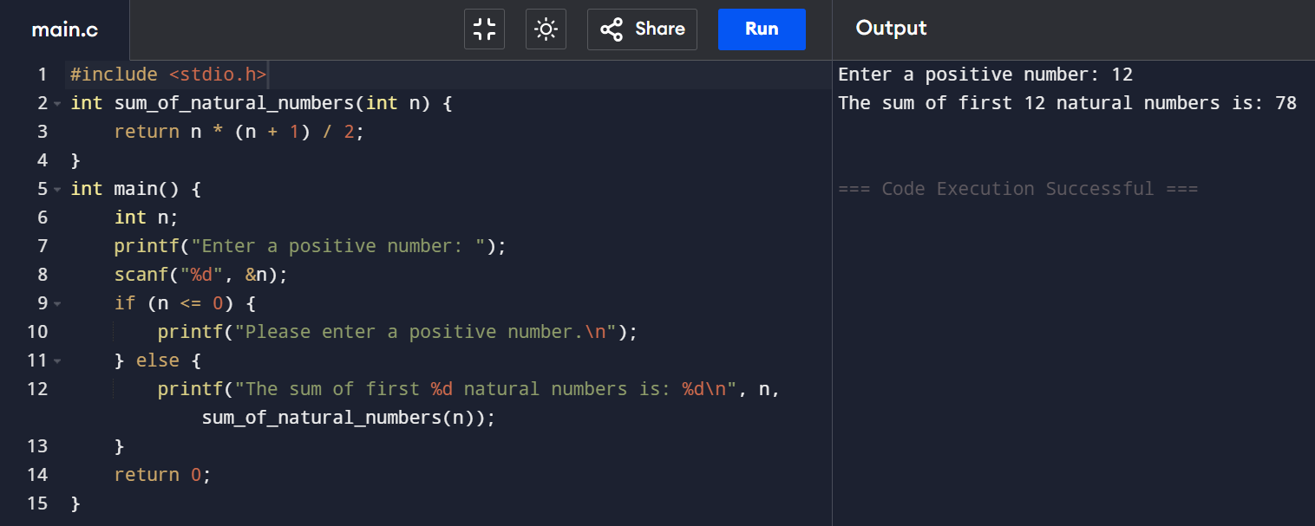

PROGRAM -10: - Write a data structure program to find sum of n odd numbers. Shubh Mittal 24/SCA/BCA/047

CODE:10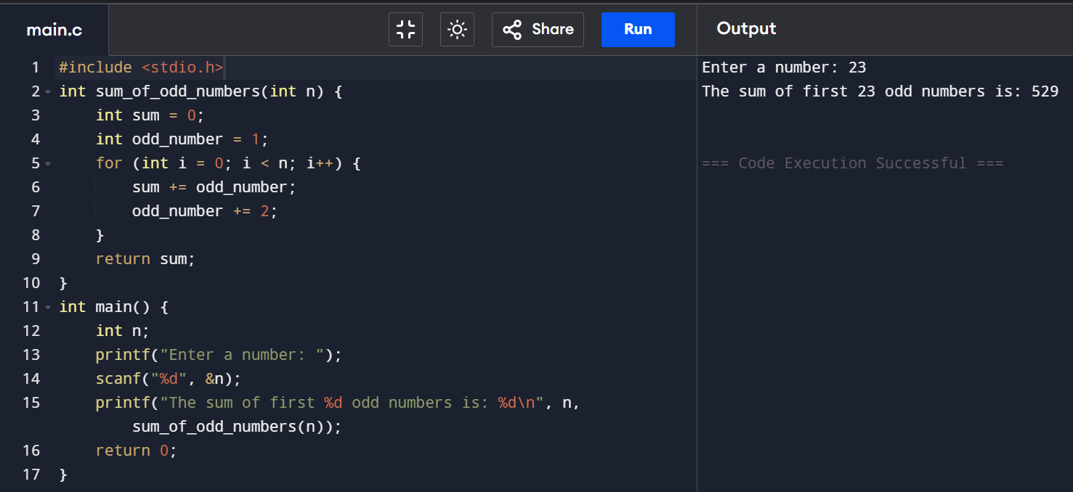

PROGRAM -11: - Write a data structure program to find sum of n even numbers. Shubh Mittal 24/SCA/BCA/047

CODE:11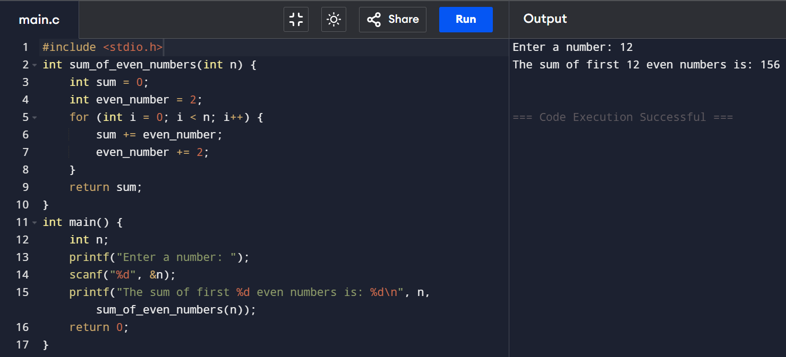

PROGRAM -12: - Write a data structure program to find list which is divisible by 3 and 5. Shubh Mittal 24/SCA/BCA/047

CODE:12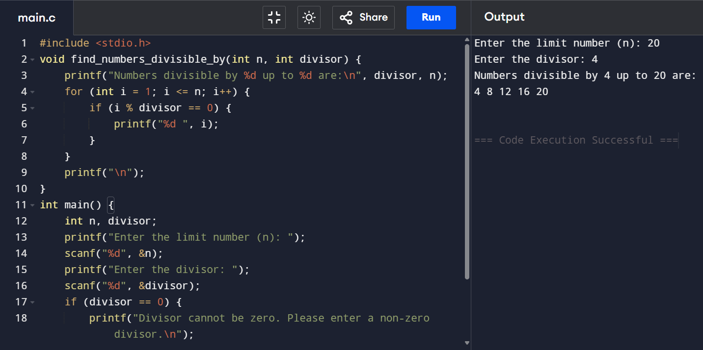

PROGRAM -13: - Write a data structure program to Traversing of an Array. Shubh Mittal 24/SCA/BCA/047

CODE:13 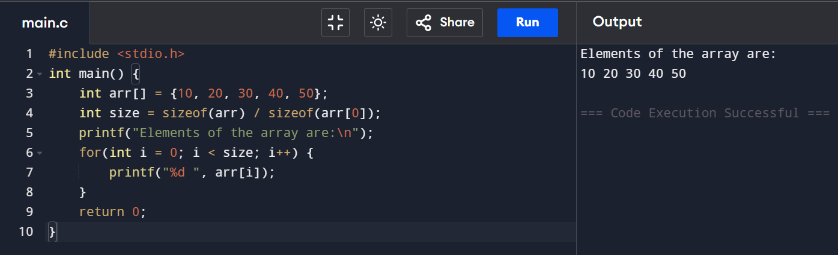

PROGRAM -14: - Write a data structure program to stack using push and pop operations. Shubh Mittal 24/SCA/BCA/047

CODE:14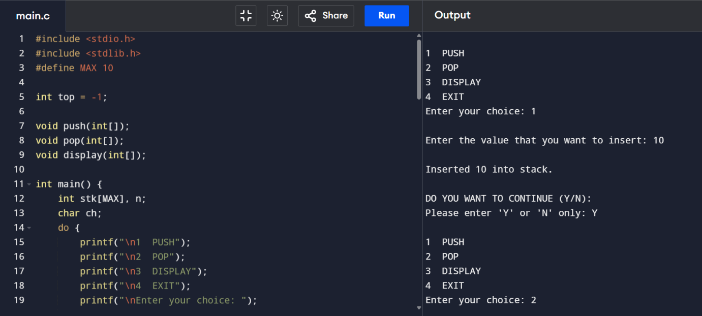

PROGRAM -15: - Write a data structure program to stack using Queue and Deque operations. Shubh Mittal 24/SCA/BCA/047

CODE:15 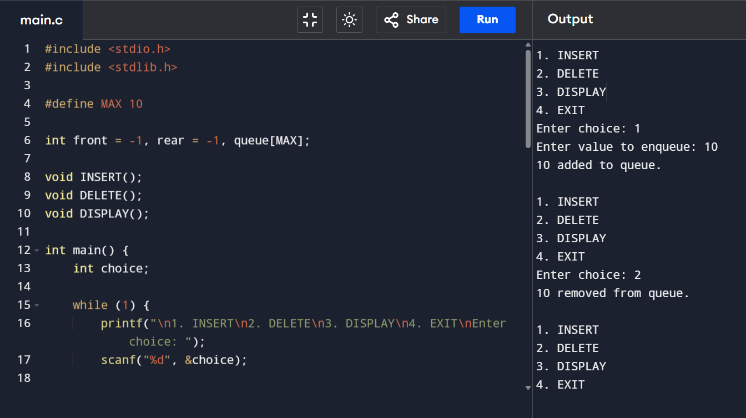

PROGRAM -16: - Write a data structure program to implement linked list. Shubh Mittal 24/SCA/BCA/047

CODE:16

